**Swagger Screenshots**

**Scenario1- Connected : yes** 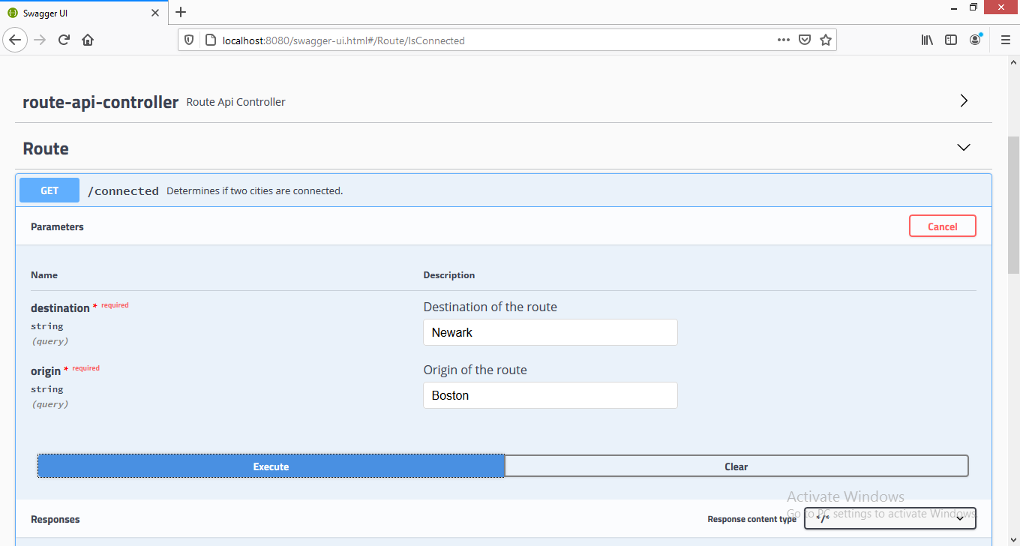

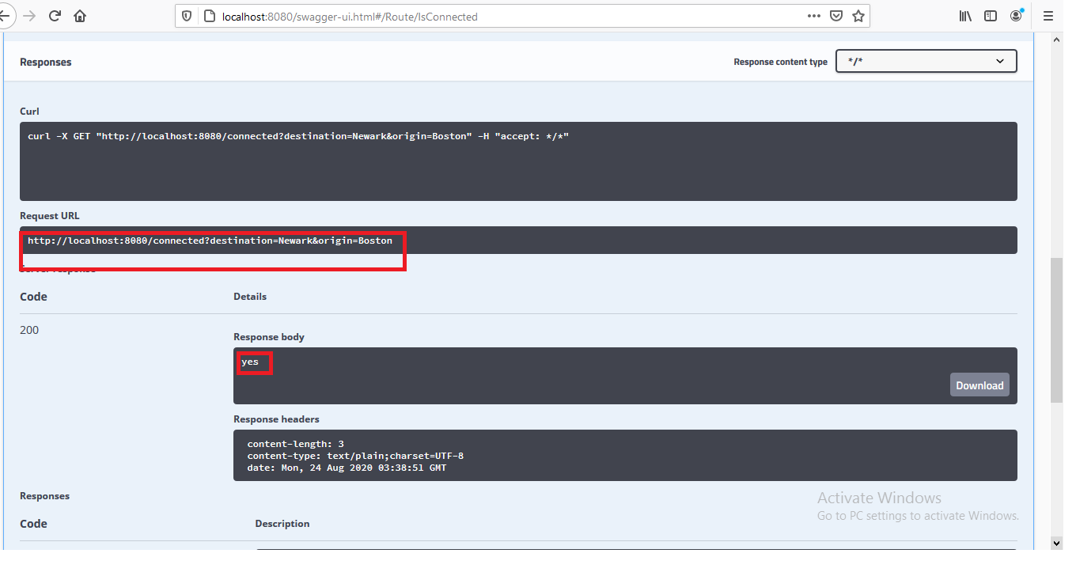

**Scenario2- Connected : no**

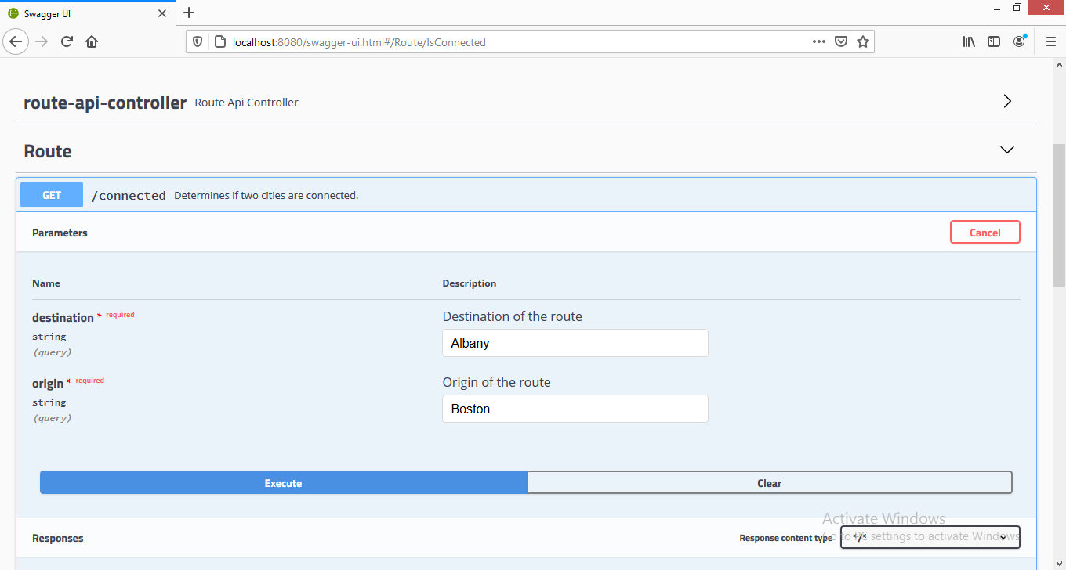

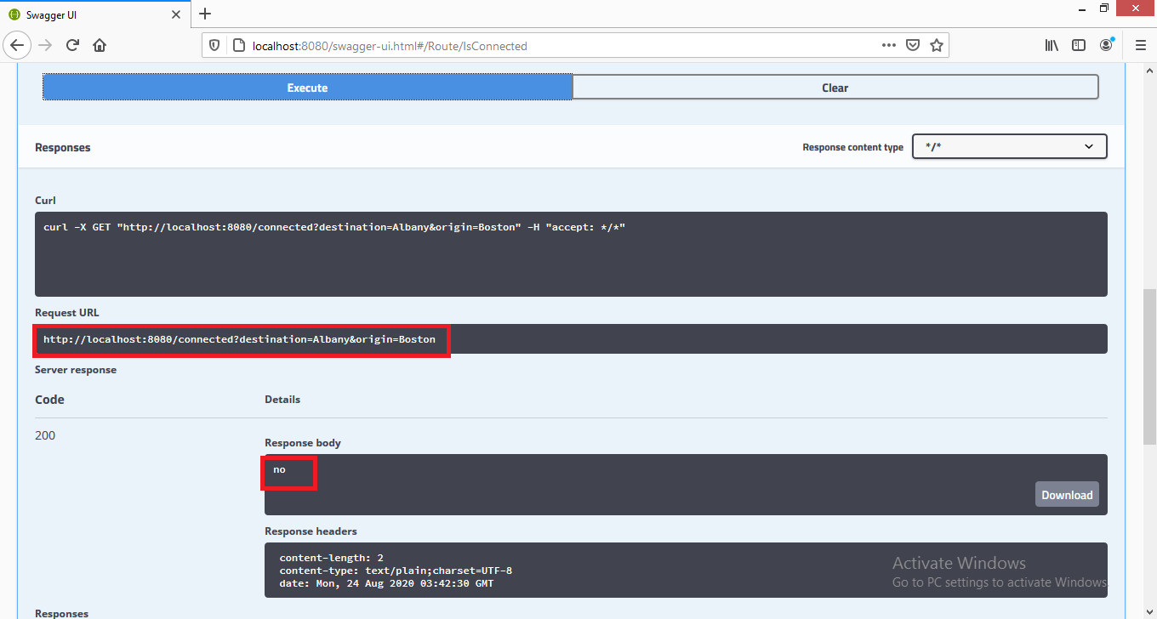

**Scenario-3: Origin and Destination cannot be same – BAD_REQUEST(400)**

